**ADDITIONAL TEST PROJECT 1 - PHILIPPINES**

**INTRODUCTION**

In this session, you will be continuing the development of the Marathon Skills 2015 application, building on what you have already developed. You will be constructing the windows form that summarize the runner’s event.

## Instructions to the Competitor

By the end of this session, you will need to have the following deliverables ready to submit so that the Marathon Skills system will be finished on time.

Make sure that you follow the provided style guide throughout all parts of the system.

Make sure that you provide appropriate validation and error messages throughout all parts of the system.

Make sure that all relevant buttons/links are working at the end of the session.

Make sure that you use appropriate naming conventions for all parts of the system as needed.

|  |
| --- |
| 1.1 - Create “RunneR registration Summary form” |
| Create an application using your preferred platform (VB.NET or C#.NET).  Create the application as outlined in “1. Runner Registration Summary Form” in the wireframe. |

### Deliverables

|  |
| --- |
| 1.2 - Create “populate runner” |
| Create the form that allows you to display registered runner on a Data Grid View together with the name of country they represent.   * When the user click on a particular records on the Data Grid view, the details will be display on the text box Registration Status, Registration ID, Runner’s Name, Birthday, Sponsor Name, Name of the country, flags and the List of events they joins. |
| **1.3 - CREATE “PRINT REGISTRATION”** |
| Print the Registration Summary |

**Wireframe**

Add a button at the Administrator menu.

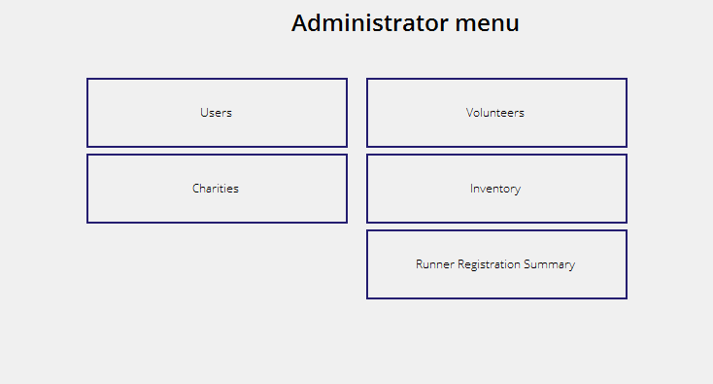

Create the Runners Registration Summary Form

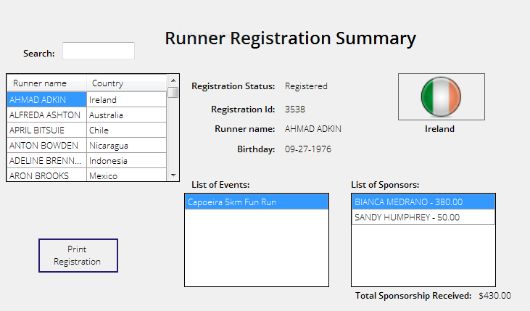

Then when the print Registration is clicked it will print the Records.

